

BIS2300

Information Systems Analysis and Design

PORTFOLIO of Individual Performance
Submission: Friday 8th February 2019, 23:55hrs (End of Week 16)

Student ID: M00652690

Name: Vishvak Baskaran

CAMPUS: Hendon
Contents

Assignments: 3
Week 1 – User Requirements 1 3
Marks (out of 10) = 3
Week 2 – User Requirements 2 3
Marks (out of 10) = 3
Week 3 – Use Cases 1 3
Marks (out of 10) = 3
Week 4 – Use Cases 2 3
Marks (out of 10) = 3
Week 5 – Use Cases 3 3
Marks (out of 10) = 3
Week 6 – Class Diagrams 1 4
Marks (out of 10) = 4
Week 7– Class Diagrams 2 4
Marks (out of 10) = 4
Week 8 – Consolidation 1 4
Marks (out of 10) = 4
Week 9 – Use Case Diagram Consolidation 4
Marks (out of 10) = 4
Week 10 – Gantt charts 4
Marks (out of 10) = 4
Week 11 – Activity Lists and Gantt chart 5
Marks (out of 10) = 5
Week 12 – Risk Analysis 5
Marks (out of 10) = 5
Week 13 – Activity Diagrams 5
Marks (out of 10) = 5
Week 14 – Sequence Diagrams 5
Marks (out of 10) = 5
Week 15 – Consolidation 5
Marks (out of 10) = 5
Own/Additional Work and Examples: 6

Assignments:

Use Case Diagram- Job Finders Case Study:

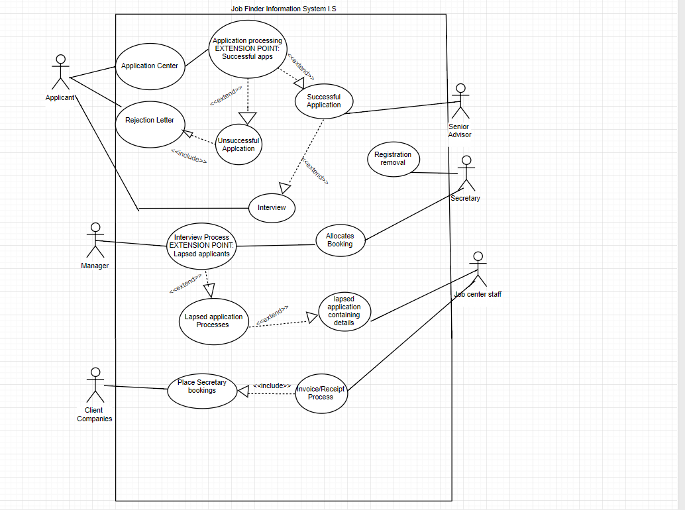

Marks (out of 10) =

Feedback Notes:

Class Diagram Library Information Systems”

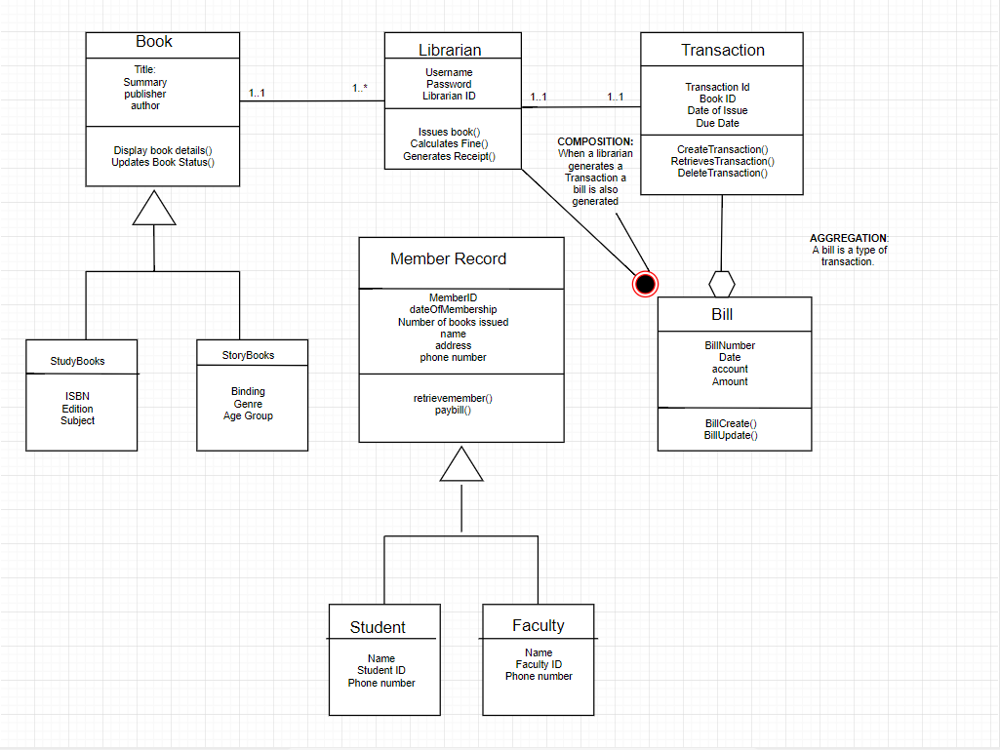

Marks (out of 10) =

Feedback Notes:

Activity Diagram Chalfont Celebrity sports club

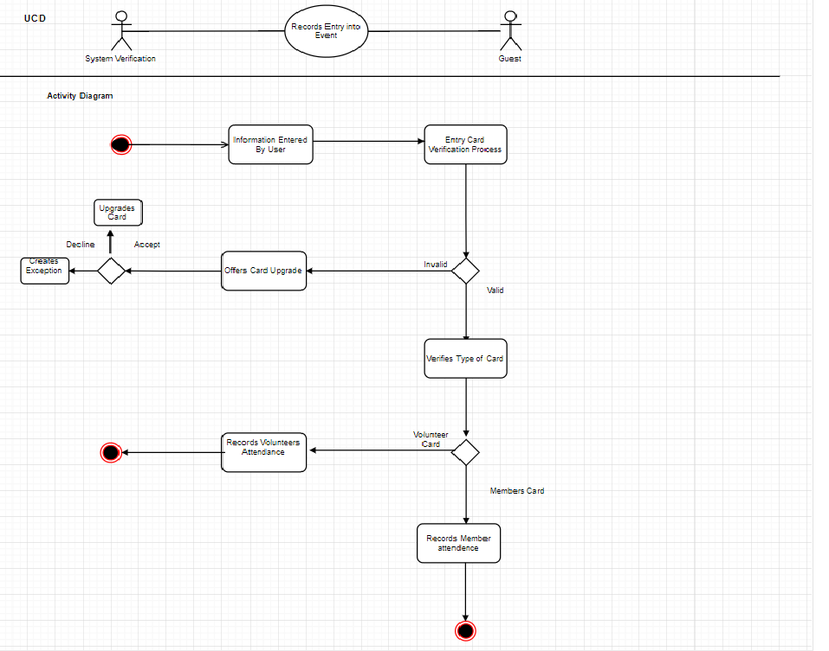

Marks (out of 10) =

Feedback Notes:

Sequence Diagram Chalfont Celebrity Sports Club
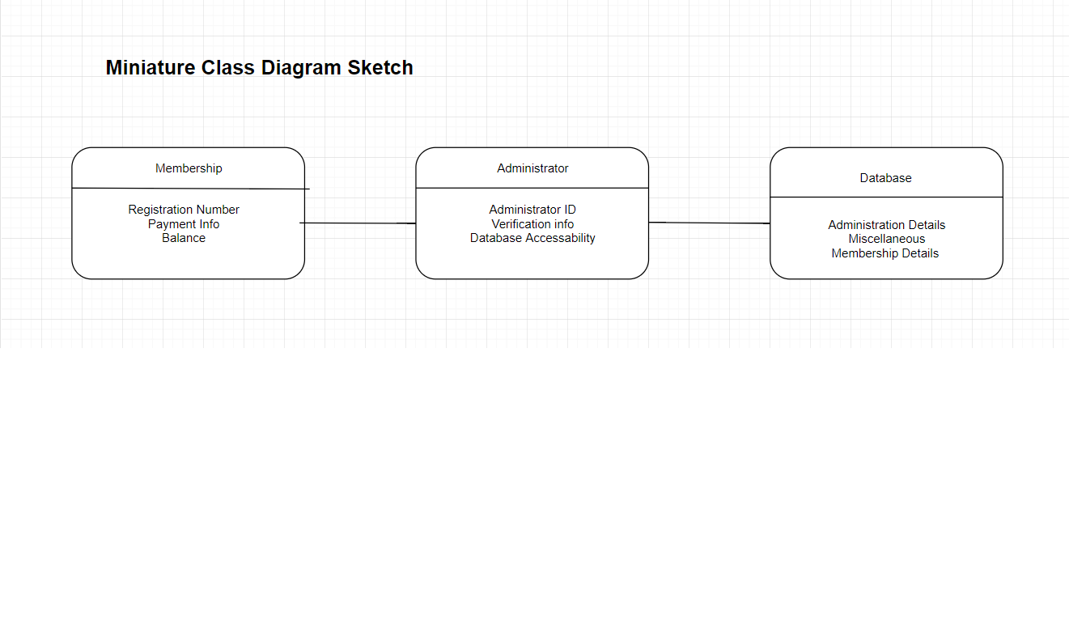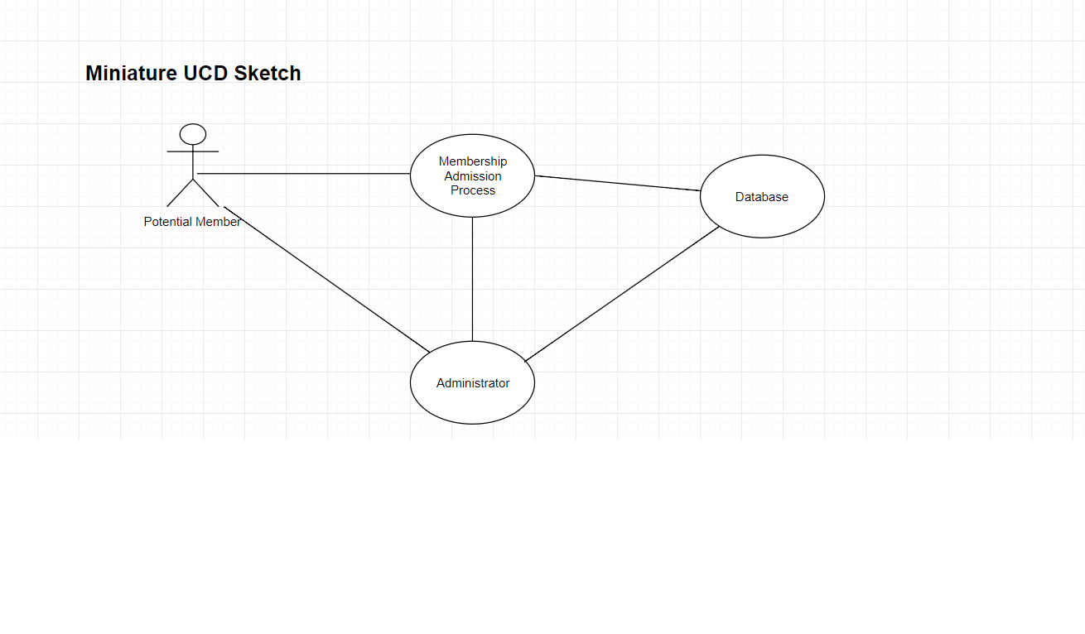

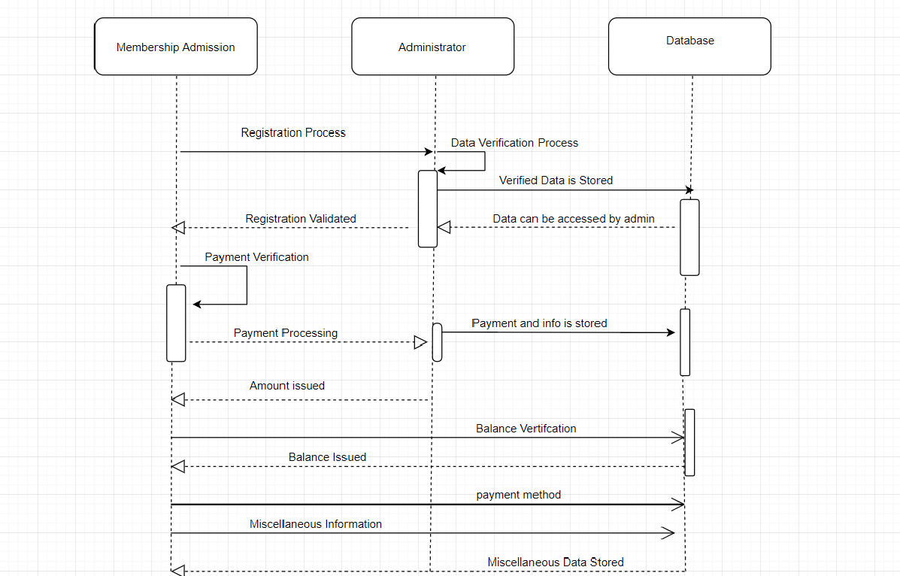

Type of frames:
Component frames: This frame depicts the internal design of a component in a sequence diagram
Package frames: This frame depicts the internal organization of a package.
Sequence Diagram frame: This frame depicts that frame contains an interaction diagram
Use Case: This frame depicts the logic of a use case diagram.

Referencing:
Ambler, S. (2010). The elements of UML 2.0 style. Cambridge [etc.]: Cambridge University Press.

Bennett, S., McRobb, S. and Farmer, R. (2010). Object-oriented systems analysis and design using UML. London: McGraw-Hill Education

Marks (out of 10) =

Feedback Notes:

Gantt Charts

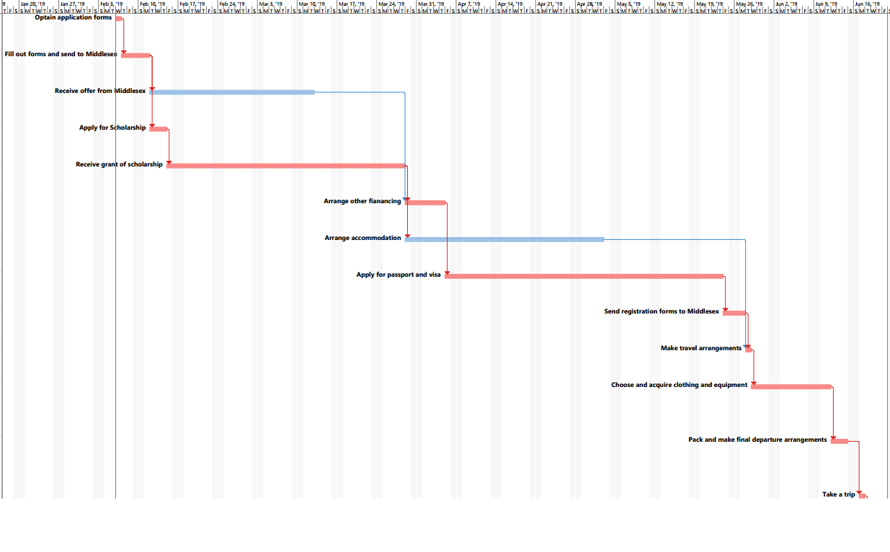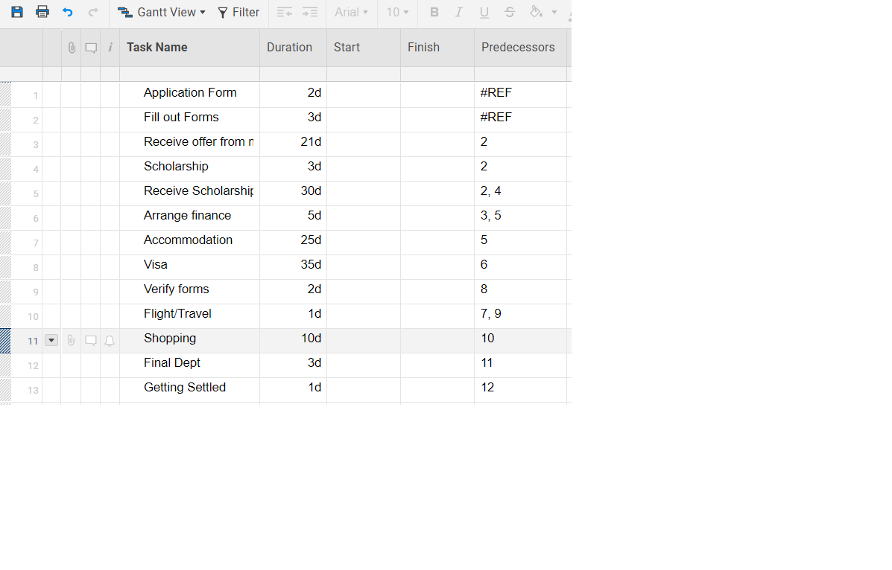

Slack Activity:
In project management, float or slack is the amount of time that a task in a project network can be delayed without causing a delay to subsequent tasks and project completion date.
Critical Activity:
Critical activity refers to the activity which occurs during a critical path within a project schedule. They are mainly determined through the implementation and utilization of the critical path method.

Critical Path:
Critical path refers to an important concept in project management. It refers to the sequence or order of schedule activities that make up the entire duration of a project. It represents the longest path through the entirety of the project and typically consists of every single activity that must be concluded from the kick off to the conclusion of a project

Referencing:
(Author), P., 2017. A guide to the Project Management Body of Knowledge (PMBOK guide) (PMBOK Guides). 6th ed. America: Project Management Institute; 6th ed edition (30 Sept. 2017).

Marks (out of 10) =

Feedback Notes:

Week 6 – Class Diagrams 1

Marks (out of 10) =

Feedback Notes:

Week 7– Class Diagrams 2

Marks (out of 10) =

Feedback Notes:

Week 8 – Consolidation 1

Marks (out of 10) =

Feedback Notes:

Week 9 – Use Case Diagram Consolidation

Marks (out of 10) =

Feedback Notes:

Week 10 – Gantt charts

Marks (out of 10) =

Feedback Notes:

Week 11 – Activity Lists and Gantt chart

Marks (out of 10) =

Feedback Notes:

Week 12 – Risk Analysis

Marks (out of 10) =

Feedback Notes:

Week 13 – Activity Diagrams

Marks (out of 10) =

Feedback Notes:

Week 14 – Sequence Diagrams

Marks (out of 10) =

Feedback Notes:

Week 15 – Consolidation

Marks (out of 10) =

Feedback Notes:

Own/Additional Work and Examples:

